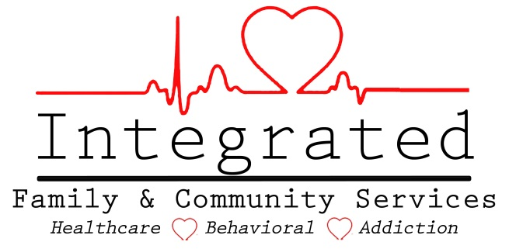

Evidence Based Practices

Prime for Life

- Treatment Method: Prime for Life
  - Description:
    - Prime For Life® is an evidence-based motivational prevention, intervention and retreatment program specifically designed for people who may be making high-risk choices. This includes but is not limited to impaired driving offenders, college students, and young people charged with alcohol and/or drug offenses. It is designed to change drinking and drug use behaviors by changing beliefs, attitudes, risk perceptions, motivations, and the knowledge of how to reduce their risk of alcohol and drug related problems throughout their lives.
  - Program Goals
    - The Goal of the Prime for life program is for the clients to:
      - Feel engaged and comfortable sharing their thoughts, feelings, and self-reflections.
      - Learn how the combination of influences and personal choices determine outcomes.
      - Learn how to make low-risk choices by using a simple tool.
      - Are given time to absorb and process the information provided.
      - Self-assess to identify their risk levels and current phase of alcohol and drug use.
      - Identify the things they value in their lives and make their own decisions about when and how to protect them.
      - Explore new beliefs and reflect on how those new beliefs may bring about positive changes.

  - Interventions Used
    - Prime for life is presented in a group format.

  - How the program is Implemented
    - Clients are given this treatment option when either their initial assessment indicates the need, or when the need is identified later in treatment. Clients who meet the criteria for .5 Education level of care are usually referred to this program.

- Training Standards for Staff
  - All staff facilitating the Prime for Life group should be sufficiently trained in the Prime for Life program so that they are found competent by the Clinical Supervisor to facilitate the program. This training can be completed via outside sources (workshops, seminars, etc.) or can be completed in-house. It is the responsibility of the Clinical Supervisor to ensure that the staff are competent before facilitating the group.

- Documentation or Links showing the chosen EBPP is research based.

  - SAMHSA's NREPP National Register of Evidence-Based Programs (http://www.nrepp.samhsa.gov/)
  - Prevention Research Institute:

http://www.primeforlife.org/Programs/PRIME_For_Life_Prevention#what_is_PFL

- Rationale for using this EBPP
  - Prime for Life is a program that can be used on clients from a variety of backgrounds. The content is easy to understand, is workbook based and comes with multimedia content to help the clients understand.

- Determining and Documenting Discharge
  - Client must successfully complete all requirements established by the curriculum in order to be evaluated for discharge from this program.

- Client Exclusion Criteria
  - Because Prime For Life® includes both prevention and intervention content, it is also designed in a way that serves universal, selective, and indicated audiences with program delivery options for each.

- Clinical Review
  - Integrated has been using this program at our agency for over two years, and can confirm that the research done by outside sources is accurate as to the effectiveness of this program.

